Riphah

NAME:SALMA RANI

Sap_id:54194

lab 3

Web App Development

**Task 1**

<!DOCTYPE html>

<html lang="en">

<head>

    <meta charset="UTF-8">

    <meta name="viewport" content="width=device-width, initial-scale=1">

    <title>Box Layout</title>

    <link href="https://cdn.jsdelivr.net/npm/bootstrap@5.3.0/dist/css/bootstrap.min.css" rel="stylesheet">

    <link rel="stylesheet" href="styles.css"> <!-- Link to external CSS file -->

</head>

<body>

    <div class="container-fluid">

        <!-- Top Header -->

        <div class="row">

            <div class="col-12 box"></div>

        </div>

        <div class="row">

            <!-- Left Sidebar -->

            <div class="col-md-2 d-none d-md-block sidebar"></div>

            <!-- Main Content -->

            <div class="col-md-8 container-box">

                <div class="col-6 box">Box 1</div>

                <div class="col-6 box">Box 2</div>

                <div class="col-6 box">Box 3</div>

                <div class="col-6 box">Box 4</div>

                <div class="col-6 box">Box 5</div>

                <div class="col-6 box">Box 6</div>

                <div class="col-6 box">Box 7</div>

            </div>

            <!-- Right Sidebar -->

            <div class="col-md-2 d-none d-md-block sidebar"></div>

        </div>

        <!-- Footer -->

        <div class="row">

            <div class="col-12 box"></div>

        </div>

    </div>

</body>

</html>

**Styles.Css**

.box {

    background-color: rgb(152, 160, 164); /* Keeping the original color */

    text-align: center;

    padding: 30px;

    font-weight: bold;

    border: 2px solid rgb(253, 247, 247); /* Proper Borders */

    margin: 10px 0; /* Spacing between boxes */

    border-radius: 5px;

    box-shadow: 2px 2px 5px rgb(253, 247, 247); /* Light Shadow */

}

.container-box {

    display: flex;

    flex-direction: column;

    align-items: center;

    justify-content: center;

    height: auto;

}

.sidebar {

    background-color: rgb(152, 160, 164);

    border-left: 2px solid rgb(248, 245, 245);

    border-right: 2px solid rgb(251, 247, 247);

min-height: 100vh;

}





**Task 2**

<!DOCTYPE html>

<html lang="en">

<head>

    <meta charset="UTF-8">

    <meta name="viewport" content="width=device-width, initial-scale=1">

    <title>Student Management</title>

    <link rel="stylesheet" href="https://cdn.jsdelivr.net/npm/bootstrap@5.3.0/dist/css/bootstrap.min.css">

    <link rel="stylesheet" href="stylee.css">

</head>

<body>

    <div class="container mt-5">

        <h2 class="text-center">Student Management</h2>

        <!-- Register Form -->

        <div class="card p-4 mt-4">

            <h5 class="mb-3">Register Form</h5>

            <form>

                <div class="row">

                    <div class="col-md-6 mb-3">

                        <label class="form-label">Name</label>

                        <input type="text" class="form-control" placeholder="Enter your name">

                    </div>

                    <div class="col-md-6 mb-3">

                        <label class="form-label">Education</label>

                        <input type="text" class="form-control" placeholder="Enter education">

                    </div>

                </div>

                <div class="row">

                    <div class="col-md-6 mb-3">

                        <label class="form-label">Address</label>

                        <input type="text" class="form-control" placeholder="Enter address">

                    </div>

                    <div class="col-md-3 mb-3">

                        <label class="form-label">Gender</label>

                        <select class="form-select">

                            <option selected>Choose...</option>

                            <option>Male</option>

                            <option>Female</option>

                        </select>

                    </div>

                    <div class="col-md-3 mb-3">

                        <label class="form-label">Age</label>

                        <input type="number" class="form-control" placeholder="Enter age">

                    </div>

                </div>

                <div class="mb-3">

                    <label class="form-label">Choose valid CNIC file</label>

                    <input type="file" class="form-control">

                </div>

                <div class="mb-3">

                    <label class="form-label">About Yourself</label>

                    <textarea class="form-control" rows="3" placeholder="Write about yourself"></textarea>

                </div>

                <div class="mb-3 form-check">

                    <input type="checkbox" class="form-check-input">

                    <label class="form-check-label">Agree to terms and conditions</label>

                </div>

                <button type="submit" class="btn btn-primary w-100">Register</button>

            </form>

        </div>

        <!-- Student Data Table -->

        <h4 class="text-center mt-5">All Students Data</h4>

        <table class="table table-striped mt-3">

            <thead class="table-light">

                <tr>

                    <th>#</th>

                    <th>Name</th>

                    <th>Education</th>

                    <th>City</th>

                    <th>Gender</th>

                    <th>Age</th>

                </tr>

            </thead>

            <tbody>

                <tr>

                    <td>1</td>

                    <td>Salma</td>

                    <td>BSCS</td>

                    <td>Islamabad</td>

                    <td>Female</td>

                    <td>20</td>

                </tr>

                <tr>

                    <td>2</td>

                    <td>Amna</td>

                    <td>BSCA</td>

                    <td>Islamabad</td>

                    <td>Female</td>

                    <td>21</td>

                </tr>

                <tr>

                    <td>3</td>

                    <td>Momna</td>

                    <td>BSCS</td>

                    <td>Islamabad</td>

                    <td>Femle</td>

                    <td>20</td>

                </tr>

                <tr>

                    <td>4</td>

                    <td>Ayesha</td>

                    <td>BSCS</td>

                    <td>Islamabad</td>

                    <td>Female</td>

                    <td>23</td>

                </tr>

            </tbody>

        </table>

    </div>

    <p class="text-center mt-5 text-primary fw-bold">Figure 153 Practice Task</p>

</body>

</html>

**Stylee.Css**

body {

    background-color: #f8f9fa;

}

.card {

    border-radius: 8px;

}

.table {

    border-radius: 5px;

    overflow: hidden;

}

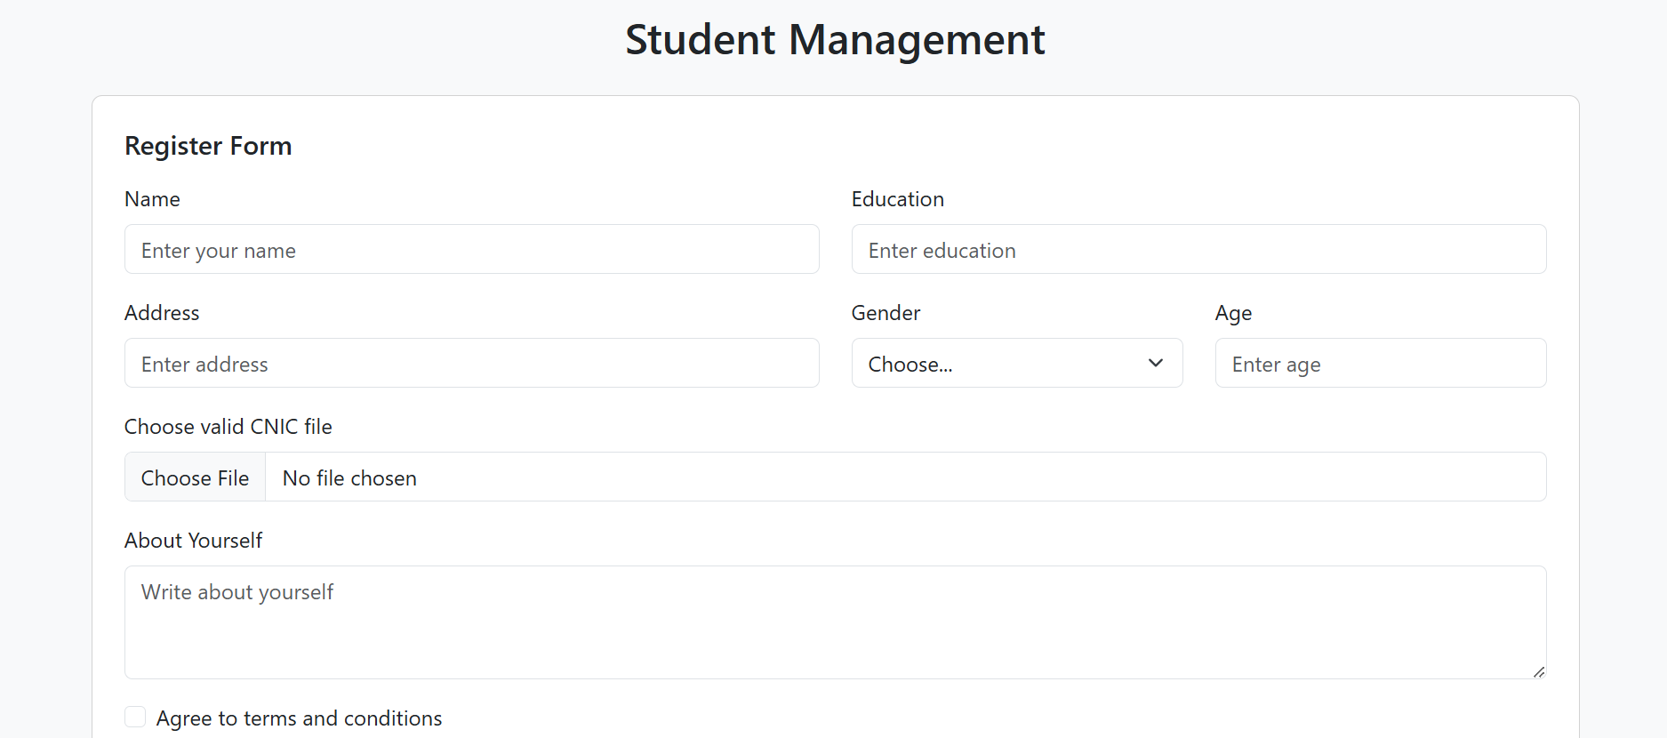

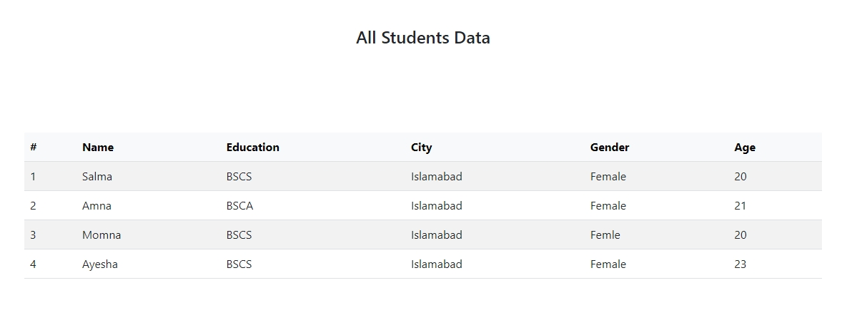

**Task 3**

<!DOCTYPE html>

<html lang="en">

<head>

    <meta charset="UTF-8">

    <meta name="viewport" content="width=device-width, initial-scale=1">

    <title>Bootstrap Notifications</title>

    <link href="https://cdn.jsdelivr.net/npm/bootstrap@5.3.0/dist/css/bootstrap.min.css" rel="stylesheet">

    <link rel="stylesheet" href="style2.css">

</head>

<body>

    <div class="container mt-5">

        <h2 class="text-center">Bootstrap Notification Alerts</h2>

        <!-- Success Notification -->

        <div class="alert alert-success alert-dismissible fade show" role="alert">

            ✅ <strong>Success!</strong> Your account has been created successfully.

            <button type="button" class="btn-close" data-bs-dismiss="alert" aria-label="Close"></button>

        </div>

        <!-- Warning Notification -->

        <div class="alert alert-warning alert-dismissible fade show" role="alert">

            ⚠ <strong>Warning!</strong> Your password is too weak. Consider using a stronger password.

            <button type="button" class="btn-close" data-bs-dismiss="alert" aria-label="Close"></button>

        </div>

        <!-- Error Notification -->

        <div class="alert alert-danger alert-dismissible fade show" role="alert">

            ❌ <strong>Error!</strong> Something went wrong. Please try again later.

            <button type="button" class="btn-close" data-bs-dismiss="alert" aria-label="Close"></button>

        </div>

    </div>

    <script src="https://cdn.jsdelivr.net/npm/bootstrap@5.3.0/dist/js/bootstrap.bundle.min.js"></script>

</body>

</html>

**Style2.Css**

body {

    background-color: #f8f9fa;

}

.container {

    max-width: 600px;

    margin: auto;

    padding: 20px;

}

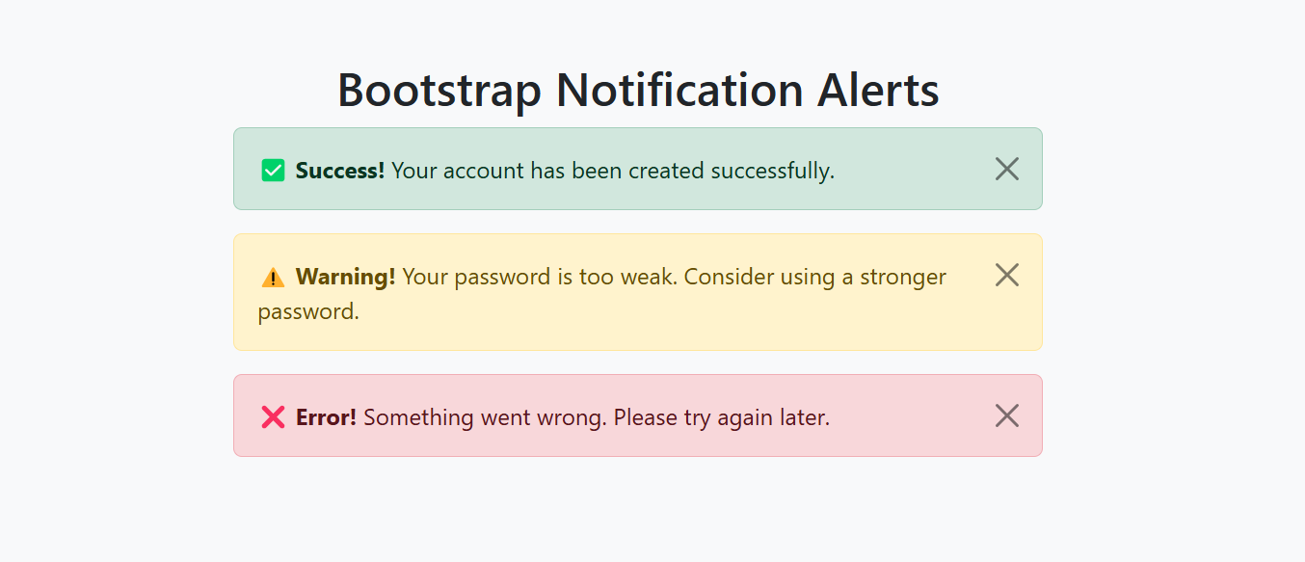

**Task 4**

<!DOCTYPE html>

<html lang="en">

<head>

<meta charset="UTF-8">

<meta name="viewport" content="width=device-width, initial-scale=1">

<title>Simple Animation & Transition</title>

<link href="https://cdn.jsdelivr.net/npm/bootstrap@5.3.0/dist/css/bootstrap.min.css" rel="stylesheet">

<link rel="stylesheet" href="style3.css"> <!-- Make sure this file exists! -->

</head>

<body>

<div class="container text-center mt-5">

<h2>Simple Animation & Transition</h2>

<!-- Animated Box -->

<div class="box mt-4"></div>

<!-- Button with Transition -->

<button class="btn btn-primary mt-4 btn-animate">Hover Me</button>

</div>

</body>

</html>

**Style3.Css**

body {

background-color: #f8f9fa;

}

/* Simple Box Animation */

.box {

width: 100px;

height: 100px;

background-color: skyblue;

margin: auto;

border-radius: 10px;

animation: bounce 1s infinite alternate;

}

/* Keyframe Animation */

@keyframes bounce {

from {

transform: translateY(0);

}

to {

transform: translateY(-20px);

}

}

/* Button Hover Transition */

.btn-animate {

transition: background-color 0.5s ease, transform 0.3s;

}

.btn-animate:hover {

background-color: navy;

transform: scale(1.1);

}

